Case Study:- Hospital Database Management System

**WE CARE EVERYONE**



Student Name: Khushi Patel

Student ID: 000964258

Subject: Data Concepts

**Table of Contents**

|  |  |  |
| --- | --- | --- |
| **Sr. No.** | **Contents** | **Page No.** |
| 1. | Introduction | 3 |
| 2. | Mission | 3 |
| 3. | Objectives | 4 |
| 4. | Database Design | 5 |
| 4.1 | Table Field and Data Dictionary | 5 |
| 4.2 | Relationships | 7 |
| 4.3 | ER Diagram | 8 |
| 5. | Database Development | 9 |
| 5.1 | Create Database | 9 |
| 5.2 | Create table and insert data in patient table | 9 |
| 5.3 | Join query | 12 |
| 6. | Conclusion | 13 |

**1.Introduction**

The project Hospital Management system includes registration of patients, storing their details into the system, and also computerized billing in the pharmacy, and labs. The software has the facility to give a unique id for every patient and stores the details of every patient and the staff automatically. It includes a search facility to know the current status of each room. User can search availability of a doctor and the details of a patient using the id. The Hospital Management System can be entered using a username and password. It is accessible either by an administrator or receptionist. Only they can add data into the database. The data can be retrieved easily. The interface is very user-friendly. The data are well protected for personal use and makes the data processing very fast. Hospital Management System is powerful, flexible, and easy to use and is designed and developed to deliver real conceivable benefits to hospitals.

**2. Mission**

The mission is to build a smart and secure hospital management platform that enhances patient experiences, facilitates smooth doctor-patient interactions, tracks medical history, and ensures accurate billing and inventory management. It will generate detailed reports to support hospital operations and improve healthcare services.

**3.Objectives**

1. **Efficient Patient Management** – Ensuring that patient records, treatment plans, and histories are well-organized and easily accessible to improve healthcare delivery.
2. **Streamlined Employee Management** – Managing hospital staff efficiently by tracking work schedules, duties, and performance to enhance productivity and service quality.
3. **Patient Appointment Scheduling** – Implementing an effective system for booking, rescheduling, and managing patient appointments to reduce wait times and improve hospital workflow.
4. **Effective Inventory & Equipment** – Ensuring proper tracking and management of medical supplies, drugs, and hospital equipment to avoid shortages and wastage.
5. **Accurate & Transparent Billing** – Establishing a reliable billing system that ensures patients are correctly charged, reduces errors, and enhances financial transparency.
6. **Optimized Department Management** – Improving coordination between different hospital departments to ensure smooth operations, better patient care, and resource utilization.

**4.Database Design**

**4.1 Tables Field and Data Dictionary**

1.Department_Info table:

2.Employee_Details table:

3.Patient_Details table:

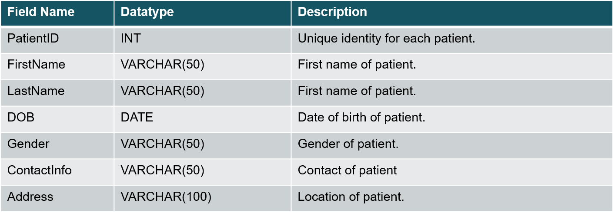

4.Patient_Appointments table:

5.Service_Table:

6.Stock_Details table:

7.Invoice_Details table:

**4.2 Relationships**

In database management, relationships define how tables are connected to each other. The three main types of relationships are One-to-One (1:1), One-to-Many (1:M), and Many-to-Many (M:N). Here’s a detailed explanation of each:

1. One-to-One (1:1) Relationship:

A one-to-one relationship means that one record in Table A is related to only one record in Table B, and vice versa.

1. One-to-Many (1:M) Relationship:

In a one-to-many relationship, one record in Table A can be related to multiple records in Table B, but each record in Table B is related to only one record in Table A.

1. Many-to-Many (M:N) Relationship:

A many-to-many relationship means that multiple records in Table A can be related to multiple records in Table B.

**4.3 ER Diagram**

**5. Database Development**

5.1 Create Database

Input:

**CREATE DATABASE test3;**

5.2 Create tables and insert data in tables

Input:

**-- Create Table: Department_Info**

**CREATE TABLE Department_Info (**

**DepartmentID INT PRIMARY KEY,**

**Department_Name VARCHAR(100)**

**);**

**-- Insert Data into Department_Info**

**INSERT INTO Department_Info (DepartmentID, Department_Name) VALUES**

**(101, 'Cardiology'),**

**(102, 'Neurology'),**

**(103, 'Pediatrics'),**

**(104, 'Radiology'),**

**(105, 'Emergency');**

Output:

5.3 Join Query

1. **Conclusion**

The Hospital Management System is a powerful solution that can help hospitals improve their operations, enhance patient satisfaction, and boost revenue. Its user-friendly interface and intuitive workflows make it easy for healthcare professionals to access and manage patient information, track resources, and optimize resource utilization. With its robust reporting and analytics capabilities, hospitals can gain insights into their performance and make data-driven decisions to drive continuous improvement.